September 11th Lesson

Materials:
- Large sheets of paper
- Markers
- Video screen

Lesson Resources:
Title | URL | Other Information
9/11 Timeline | http://www.history.com/topics/9-11-attacks/videos#911-timeline | Video (History Channel) 4:54
Statue of Liberty “It’s okay”  *Use for children group | http://www.loc.gov/exhibits/911/images/sep0175s.jpg | 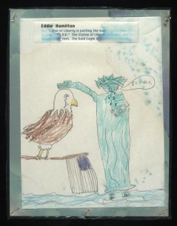  Eddie Hamilton, third grader  Sequoyah Elementary School, Knoxville, Tennessee.
Bisvera pratiti Mosalamana Amerikara biruddhe, rukhe daraile Musalamanera bijaya anibarya, Osama bina Ladena.  "If each Muslim resists America, then victory is certain for them. Osama Bin Laden."  *Use for President group | http://www.loc.gov/exhibits/911/images/sep0187s.jpg | 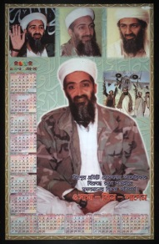  September 20, 2001. [Bengali] poster calendar.
"America's Bloodiest Day"  *Use for military example | http://www.loc.gov/exhibits/911/images/sep0006.jpg | 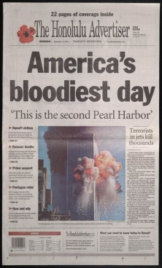  Honolulu Advertiser  (Honolulu, Hawaii)  September 12, 2001.  Courtesy of Honolulu Advertiser.
Mother and daughter  *Use for parents group | http://www.loc.gov/exhibits/911/images/01745r.jpg | 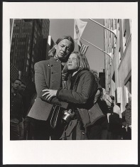  October 30, 2001  World Trade Center series, New York City, November 14, 2001
Memorial to Matthew Diaz following September 11th terrorists attack, 2001, New York City, 2001  *Use for New Yorker Group | http://www.loc.gov/exhibits/911/images/01938r.jpg | 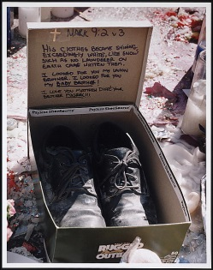
Patriot Act Political Cartoon  *Use for lawmakers group | http://www.loc.gov/exhibits/telnaes/telnaes-tab.html | 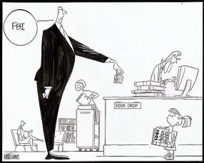  [FBI, child, library bookdrop], Ann Telnaes, June 25, 2002.

Procedure:
Time | Activity | Procedure
Homework from previous class period | Background of 9/11 and document to accompany group for lesson | - Read short article  - Complete “Primary Source Analysis” questions specific to the type of source
6-7 minutes | Context video | - Watch context video: 9/11 Timeline from the History Channel
5-6 minutes | Teacher(s) scaffold “Point of View” web | Teacher(s) Military perspective of 9/11 – image will be shown using the LCD projector to the class as a whole
6 minutes | Students create web and put on the board (using white paper and markers) | - 5 groups of 4 (each has a different stakeholder group) give reactions to the event  - President  - New Yorkers  - Parents  - Children  - Law makers
10 minutes | Discussion of interactions | - Each group shares 1-2 of their specific stakeholder group’s reactions  - Teacher writes reactions on central 9/11 point of view web
20 minutes | Writing assignment with example | - Write a paragraph (100 word minimum) explaining a person from one of the stakeholder groups actions in response to the event  - Will be looking for:  - Historical accuracy  - Use of facts  - Description of events  - Description of individuals perspective  - Proper use of the English language
Homework | Learn our method of grading student writing | - Students will read samples of writing assignment using military circle of viewpoints example  - One sample will be an exemplar  - Other example of lower caliber will showcase method of grading
Bell-Ringer for following class period | Student writing self-evaluation | - Hand back paragraphs  - Post-it: One thing I did well with my paragraph was_________. One thing I need to work on with my writing in the future is _________.

Example of “Circle of Viewpoints” for Military Perspective

