Name________________________________________ Date_______________

FAQ About September 11, 2001
What was the World Trade Center? | The World Trade Center (WTC) was a 16-acre commercial complex in lower Manhattan that contained seven buildings, a large plaza, and an underground shopping mall that connected six of the buildings. The centerpieces of the complex were the Twin Towers. On September 11, 2001, the entire complex was destroyed in a terrorist attack that has come to be referred to as “9/11”.
What were the Twin Towers? | The Twin Towers were the tallest buildings in New York City. At 110 stories each, 1 WTC (North Tower) and 2 WTC (South Tower) provided nearly 10 million square feet of office space for approximately 35,000 people and 430 companies. For a brief period upon their completion in 1973, they were the tallest buildings in the world. They attracted roughly 70,000 commuters and tourists daily.  The towers had been the target of an attack before 9/11. On February 26, 1993, terrorists with links to an Islamist extremist group detonated explosives in a van parked underneath the WTC. Six people were killed and thousands were injured.
What happened on 9/11? | “9/11” is shorthand for four coordinated terrorist attacks carried out by al-Qaeda, an Islamist extremist group, that occurred on the morning of September 11, 2001. The attacks killed 2,977 people.  On the morning of September 11, 2001, nineteen terrorists from the Islamist extremist group, al-Qaeda, hijacked four commercial airplanes, deliberately crashing two of the planes into the upper floors of the North and South Towers of the World Trade Center complex and a third plane into the Pentagon in Arlington, VA. The Twin Towers ultimately collapsed because of the damage sustained from the impacts and the resulting fires. After learning about the other attacks, passengers on the fourth hijacked plane, Flight 93, fought back, and the plane was crashed into an empty field in western Pennsylvania about 20 minutes, by air, from Washington, DC where we believe it was headed.  The attacks killed individuals from 93 nations. 2,753 people were killed in New York, 184 people were killed at the Pentagon, and 40 people were killed on Flight 93.
What happened at the World Trade Center on 9/11? | The hijacked Flight 11 was crashed into floors 93 to 99 of the North Tower (1 WTC) at 8:46 am. The hijacked Flight 175 struck floors 77 to 85 of the South Tower (2 WTC) 17 minutes later at 9:03 am. When the towers were struck, between 16,400 and 18,000 people were in the WTC complex. Of those, the vast majority evacuated safely. As they rushed out, first responders - members of the New York City Fire Department (FDNY), New York City Police Department (NYPD), Port Authority Police Department (PAPD), and other agencies - rushed in trying to save those still trapped or injured.  The fires from the impacts, intensified by the planes’ burning jet fuel, were incredibly hot. They weakened the steel support trusses, which attached each of the floors to the buildings’ exterior walls. Along with the initial damage to the buildings’ structural columns, this ultimately caused both towers to collapse. The five other buildings in the WTC complex were also destroyed because of damage sustained when the Twin Towers fell.
What is al-Qaeda? | Al-Qaeda is an international Islamist extremist terrorist network founded in the late 1980’s by Osama bin Laden, who was killed in a U.S. military operation on May 1, 2011, and others who were involved in the war against the Soviet Union in Afghanistan. Their aim has been to overthrow governments in the Middle East, and elsewhere in the Muslim world, which do not strictly enforce a religiously-sanctioned political and social order. Attacks against the United States were intended to reduce American support for many of these governments; US support was viewed by al-Qaeda as a major obstacle to creating a global order under Islamic authority.  They have claimed responsibility for numerous terrorist attacks since the early 1990’s, including the 1998 U.S. Embassy bombings in Kenya and Tanzania, the 2000 attack on the USS Cole, and the 9/11 attacks. They have also aligned themselves with and inspired other terrorist groups who have carried out attacks, including the 2002 Bali bombing, the 2004 Madrid train bombing, the 2007 London bombings, and the 2008 Mumbai terrorist attacks, among many others.
Source: http://www.911memorial.org/faq-about-911

Children Group
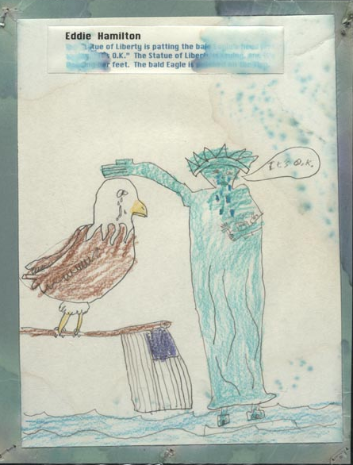
Eddie Hamilton, third grader
Sequoyah Elementary School, Knoxville, Tennessee.
http://www.loc.gov/exhibits/911/images/sep0175s.jpg

Observe:
- Describe what you see.

- What words do you see?

Reflect:
- Why do you think this drawing was made?

- Who do you think was the audience for this drawing?

Questions:
- What do you wonder about…Who? What? Where? Why? How?

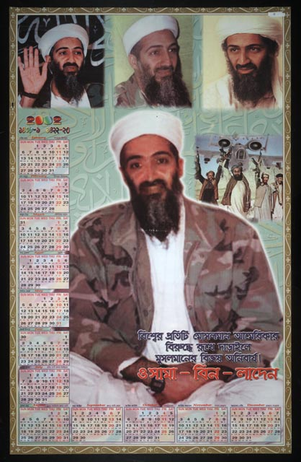
President Group
Bisvera pratiti Mosalamana Amerikara biruddhe, rukhe daraile Musalamanera bijaya anibarya, Osama bina Ladena.
"If each Muslim resists America, then victory is certain for them. Osama Bin Laden."
September 20, 2001. [Bengali] poster calendar.

http://www.loc.gov/exhibits/911/images/sep0187s.jpg

Observe:
- Describe what you see.

- What people and objects are shown?

Reflect:
- Why do you think this calendar was made?

- Who do you think was the audience for this calendar?

Questions:
- What do you wonder about…Who? What? Where? Why? How?
Parents Group
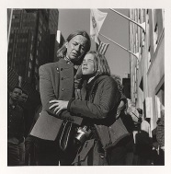

Mother and Daughter
October 30, 2001
World Trade Center series, New York City, November 14, 2001

http://www.loc.gov/exhibits/911/images/01745r.jpg

Observe:
- Describe what you see.

- What is the physical setting?

Reflect:
- What is happening in this photograph?

- Who do you think was the audience for this photograph?

Questions:
- What do you wonder about…Who? What? Where? Why? How?

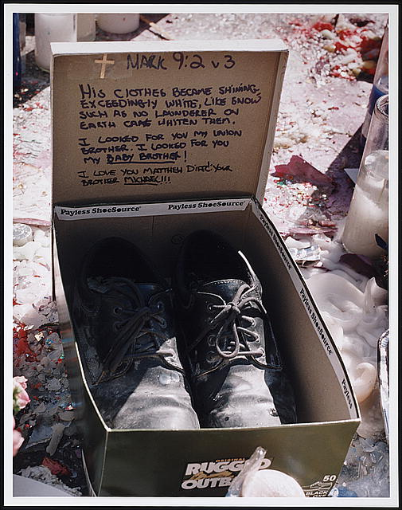
New Yorker Group

Memorial to Matthew Diaz following September 11th terrorists attack, 2001, New York City, 2001

http://www.loc.gov/exhibits/911/images/01938r.jpg

Observe:
- Describe what you see.

- What words do you see?

Reflect:
- What can you learn from examining this photograph?

- Who do you think was the audience for this photograph?

Questions:
- What do you wonder about…Who? What? Where? Why? How?
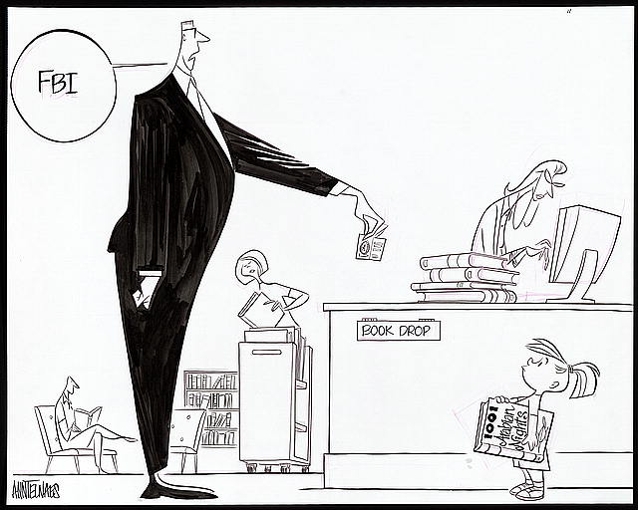
Lawmaker Group

Patriot Act Political Cartoon
Ann Telnaes, June 25, 2002.

http://www.loc.gov/exhibits/telnaes/telnaes-tab.html

Observe:
- Describe what you see.

- What words do you see?

Reflect:
- What is happening in this cartoon?

- What issue do you think this cartoon is about?

Questions:
- What do you wonder about…Who? What? Where? Why? How?

